**Customer Churn Predictions**

**Introduction**

Customer churn, also known as customer attrition, refers to the phenomenon where customers discontinue their business relationship with a company. In today's highly competitive business landscape, understanding and predicting customer churn is of paramount importance for organizations across various industries. By identifying customers at risk of churning, businesses can take proactive measures to retain them, ultimately saving costs and increasing profitability.

## Understanding Customer Churn

### Customer Satisfaction:

Customer satisfaction is a pivotal factor in customer churn. When customers are dissatisfied with a company's products or services, they are more likely to leave. It's essential for businesses to assess customer satisfaction through surveys, feedback mechanisms, and sentiment analysis of customer reviews. By understanding what aspects of the customer experience are causing dissatisfaction, companies can take corrective actions to improve their offerings and retain customers.

### Product/Service Quality:

Subpar product quality or inadequate services can be a significant driver of customer churn. Businesses should closely monitor the quality of their offerings and continuously seek ways to enhance them. Quality assurance processes, regular customer feedback analysis, and benchmarking against industry standards are all methods for ensuring the products and services meet customer expectations.

### Pricing and Competitor Offers:

Pricing plays a crucial role in customer retention. Customers may churn if they find better pricing or more attractive offers from competitors. It's vital for companies to conduct pricing analyses to ensure their pricing strategies are competitive and appealing to customers. Regularly monitoring the pricing strategies of competitors can also help companies stay competitive.

### Customer Engagement:

Customer engagement is a key factor in reducing churn. Engaged customers are more likely to remain loyal to a company. Monitoring customer engagement involves J8UDRI metrics like customer interactions, website visits, app usage, and response to marketing campaigns. By tracking these metrics, businesses can identify customers who are disengaging and take steps to re-engage them.

### Demographics and Customer Segmentation:

Not all customers are the same, and customer churn can vary significantly among different segments. To effectively predict and mitigate churn, companies often segment their customer base based on demographics, behavior, or other relevant criteria. This allows for the creation of tailored strategies to address the unique needs and preferences of each segment. For example, the needs of new customers may differ from those of long-term, loyal customers, and the strategies to retain them should reflect these differences.

## Predictive Analytics for Customer Churn

### Data Collection:

Data collection is the foundation of any predictive churn model. It involves gathering a diverse set of data, including customer profiles, transaction history, customer service interactions, and feedback. Companies can also integrate external data sources, such as industry benchmarks, economic indicators, and social media sentiment, to gain a comprehensive view of customer behavior.

### Data Preprocessing:

Before analysis can begin, data must be cleaned and prepared. This process includes handling missing data, encoding categorical variables, and scaling features. Clean data is essential for building an accurate churn prediction model.

### Feature Selection:

Feature selection is a critical step in building a predictive model. Not all data features are equally important in predicting churn. Through exploratory data analysis and feature engineering, companies identify the most influential features that contribute to churn. This step allows for the creation of a more focused and efficient model.

### Model Selection:

Choosing the right machine learning algorithm is crucial. The choice of algorithm depends on the specific nature of the data and the problem at hand. Common models for churn prediction include logistic regression, decision trees, random forests, support vector machines, and neural networks. The selection of the model should be based on the characteristics of the data and the desired level of interpretability.

### Model Training:

Once a model is selected, it is trained using historical data. During training, the model learns to recognize patterns and relationships in the data that are indicative of potential churn. The model's performance improves with more data and experience.

### Model Evaluation:

The performance of the churn prediction model must be rigorously assessed to ensure its effectiveness. Common evaluation metrics include accuracy, precision, recall, F1-score, and ROC-AUC. Cross-validation techniques are often employed to ensure the model's robustness and generalization to new data.

### Deployment:

After a model is successfully trained and evaluated, it can be deployed to make real-time predictions. Integration with customer databases or CRM systems allows companies to utilize churn predictions to take proactive actions in retaining at-risk customers.

### Continuous Monitoring:

Churn prediction is an ongoing process. Customer behavior and factors influencing churn can change over time. Companies must regularly update the model with new data and reevaluate its performance. Adjustments to the model and retention strategies should be made as needed to adapt to changing circumstances.

## Benefits of Customer Churn Predictions

### Cost Reduction:

One of the most immediate benefits of churn predictions is the potential for cost reduction. Acquiring new customers is typically more expensive than retaining existing ones. By identifying customers at risk of churning and implementing targeted retention strategies, companies can save on the high costs associated with customer acquisition.

### Revenue Retention:

Retaining existing customers is a revenue-saving strategy. Loyal customers tend to spend more over time, and increasing customer retention rates can have a significant positive impact on the bottom line.

### Improved Customer Service:

### Proactive churn prevention strategies often involve enhancing customer service and satisfaction. Customers who feel valued and well-served are more likely to stay loyal. This not only reduces churn but also promotes positive word-of-mouth and referrals.

### Competitive Advantage:

Companies that effectively predict and reduce churn gain a competitive advantage in their industry. Customer retention is a key differentiator, and businesses that excel in this area are better positioned to outperform competitors.

### Data-Driven Decision Making:

Churn predictions drive data-driven decision-making processes. Companies can use these insights to allocate resources more efficiently, optimize marketing campaigns, and tailor their offerings to meet customer needs. This data-driven approach empowers businesses to make informed decisions that improve customer retention and overall performance.

## Program:

import numpy as np

import pandas as pd

import matplotlib.pyplot as plt

import seaborn as sns

import missingno as msno

import warnings

warnings.filterwarnings("ignore")

from sklearn.experimental import enable_iterative_imputer

from sklearn.impute import IterativeImputer

from sklearn.preprocessing import LabelEncoder

pd.options.display.max_columns = None

data = pd.read_csv("/content/WA_Fn-UseC_-Telco-Customer-Churn.csv")

data.head()

data.info()

data.drop('customerID', axis = 1, inplace =True)set(''.join(data['TotalCharges'].tolist()))

data['TotalCharges'] = data['TotalCharges'].replace(' ', np.nan)

data['TotalCharges'] = data['TotalCharges'].astype('float')

data.info()

data.columns = data.columns.str.lower()

data.columns

num_cols = ['tenure','monthlycharges', 'totalcharges']

data[num_cols].describe().T

data[[col for col in data.columns.difference(num_cols) if col !='seniorcitizen']].describe().T

data['seniorcitizen'].value_counts()

ord_cols = ['dependents', 'gender', 'paperlessbilling', 'partner', 'phoneservice']

label = 'churn'

cat_cols = ['seniorcitizen', 'multiplelines', 'internetservice', 'onlinesecurity', 'onlinebackup', 'deviceprotection', 'techsupport', 'streamingtv', 'streamingmovies', 'contract','paymentmethod']

plt.figure(figsize = (15, 4))

for i, col in enumerate(num_cols):

plt.subplot(1, 3, i+1)

sns.histplot(data, x= col, color = 'red', alpha = 0.2, kde = True)

plt.tight_layout()

plt.show()

plt.figure(figsize = (15, 4))

for i, col in enumerate(num_cols):

plt.subplot(1, 3, i+1)

sns.rugplot(data, x = col, hue= label, height = 0.1)

sns.boxplot(data, x = col, width = 0.3)

plt.tight_layout()

plt.show()

plt.figure(figsize = (15, 4))

for i, col in enumerate(num_cols):

plt.subplot(1, 3, i+1)

sns.boxplot(data, x = label, y = col, width = 0.4)

plt.tight_layout()

plt.show()

plt.figure(figsize = (15, 26))

for i, col in enumerate(data.columns.difference(num_cols)[1:]):

plt.subplot(6, 3, i+1)

ax = sns.countplot(data, x = col, hue = label)

ax.bar_label(ax.containers[0])

ax.bar_label(ax.containers[1])

plt.xticks(rotation = 15)

plt.tight_layout()

plt.show()

plt.figure(figsize = (4,4))

ax = sns.countplot(data, x = label)

ax.bar_label(ax.containers[0])

plt.show()

def lencoder(col):

le = LabelEncoder()

data[col] = le.fit_transform(data[col])

return data[col]

for col in ord_cols:

data[col] = lencoder(col)

data['churn'] = lencoder('churn')

ohe_data = pd.get_dummies(data)

ohe_data[ohe_data.select_dtypes(include = 'bool').columns] = ohe_data[ohe_data.select_dtypes(include = 'bool').columns].astype('int')

data = ohe_data.copy()

imp_mean = IterativeImputer(random_state = 42)

data_impute = imp_mean.fit_transform(data)

data = pd.DataFrame(data_impute, columns = data.columns)

!pip -q install pycaret

!pip -q install --upgrade scipy

!pip -q install --upgrade yellowbrick

import pycaret

from pycaret.classification import *

s = setup(data, target = 'churn', session_id = 42, data_split_stratify=True)

best_model = compare_models(sort = 'AUC')

print(best_model)

plt.figure(figsize = (7, 4))

plot_model(best_model, plot = 'feature')

plt.figure(figsize = (7, 4))

plot_model(best_model, plot = 'auc')

plt.figure(figsize = (4,3))

plot_model(best_model, plot = 'confusion_matrix')

def calculate_profit(y, y_pred):

tp = np.where((y_pred == 1) & (y == 1), 4000, 0)

fp = np.where((y_pred == 1) & (y == 0), -1000, 0)

return np.sum([tp,fp])

add_metric('profit', 'Profit', calculate_profit)

best_model = compare_models(sort = 'Profit')

plt.figure(figsize = (4,3))

plot_model(best_model, plot = 'confusion_matrix')

save_model(best_model, 'churn-predict')

## visualization of Prediction:

**visualization of payment range between tenure, monthly charges and total charges:**

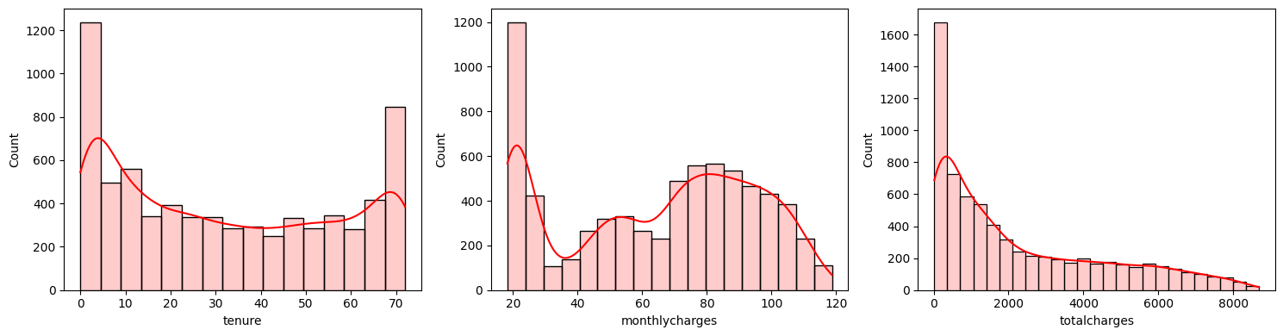

**The visualization between users and non-users:**

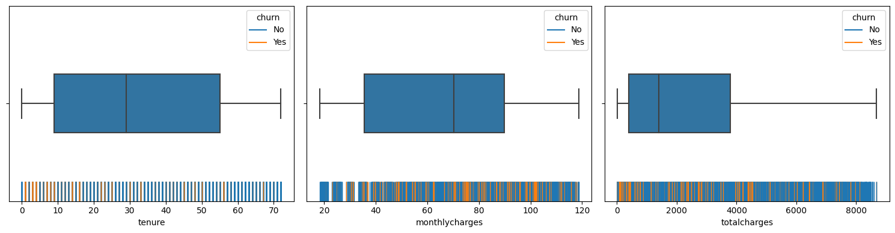

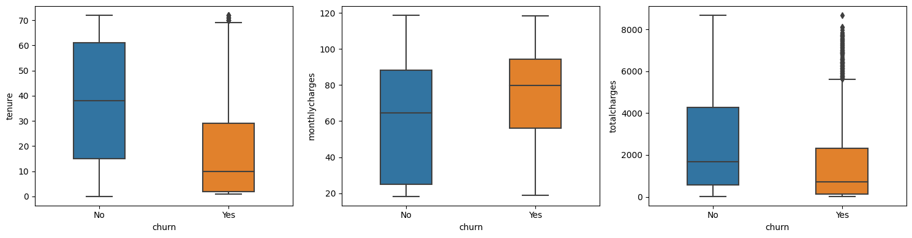

**The differences between the users and non-users in the given columns:**

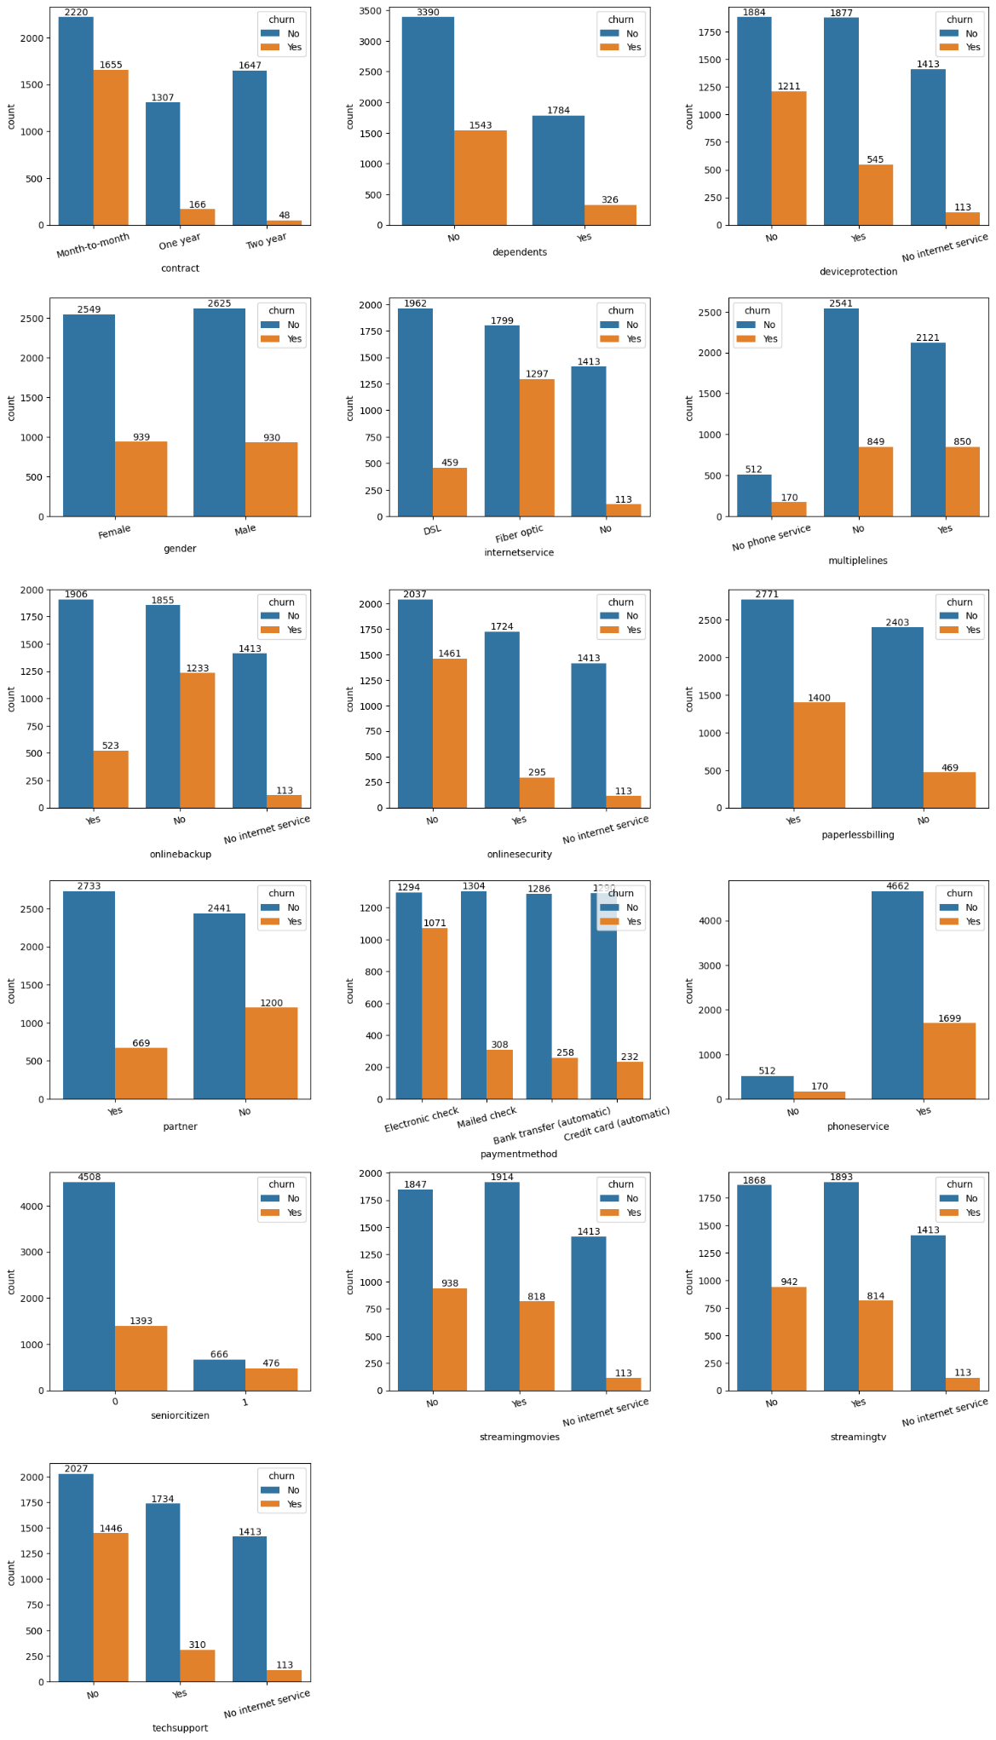

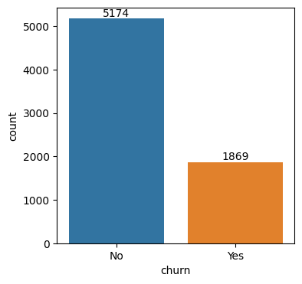

**Features and variable importence:**

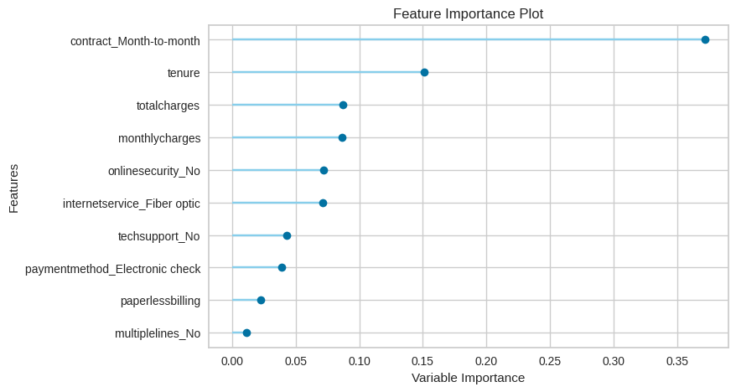

**The gradient boosting classifier between positive and negative rate:**

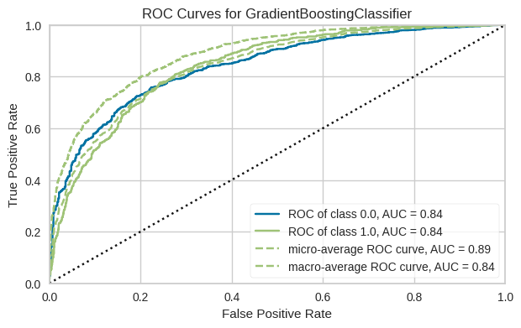

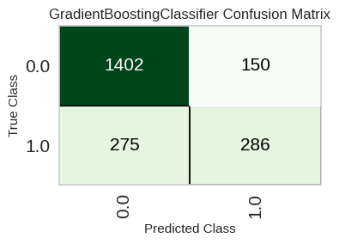

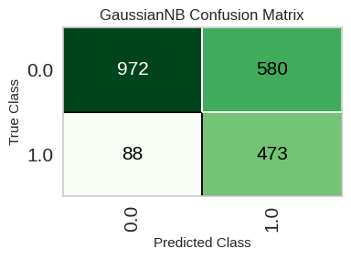

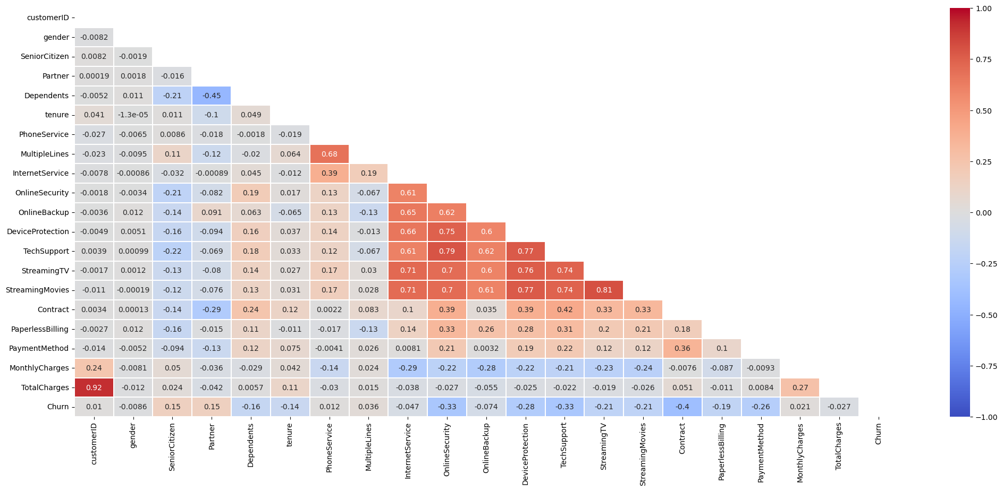

## Conclusion:

Incorporating customer churn predictions into your business strategy is a proactive step towards long-term success in today's competitive markets. Understanding the factors contributing to churn, using predictive analytics to build accurate models, and implementing targeted retention strategies can significantly enhance customer satisfaction, reduce costs, and ultimately contribute to the growth and profitability of the business. Businesses that prioritize customer retention through data-driven approaches are better equipped to thrive in an ever-evolving marketplace.